`

Tennessee Board of Regents

New Employee Orientation 2014

EXEMPT

The Tennessee Board of Regents is the nation’s sixth largest higher education system, governing 46 post-secondary educational institutions. The TBR system includes six universities, 13 two-year colleges and 27 colleges of applied technology, providing programs in 90 of Tennessee’s 95 counties to more than 200,000 students.

agenda

 New Hire Paperwork

Things to Know
- Genesco Building
- TBR & State Websites
- Paycheck Stubs

Policies
- Drug Free Workplace
- Computer Usage
- Outside Employment

Training
- Sexual Harassment
- Title VI

Benefits Overview
- Employer Provided
- Voluntary

Review Checklist

Distribution Items
- Title IX Fact Sheet
- Title VI Handout
- Fraud Brochure
- Organizational Charts
- Phone List
- Job Description
NEW HIRE PAPERWORK

- Employee Data Form

- Voluntary Self-Identification Form

- I-9

- W-4

- Direct Deposit Authorization

- Designation of Beneficiary Form (notary provided)

- Computer Account Application

- Office Key Request

- Payroll Deduction Authorization Form

THINGS TO KNOW

- Genesco Building
- Normal building hours are 6:00am – 6:30pm. Employees requiring access before or after hours may enter through the back doors by announcing their arrival to the security staff.
- Employees leaving through the front of the building after 6:30pm will need to exit the first set of double doors and go through the door on the left (inside the breezeway) to gain access to the exterior of the building, as the furthest/exterior doors will be locked.
- Employees may park in any undesignated spot in the front, overflow, and back lots (the tree-lined, parallel parking in the very front is for visitors only). Please adhere to all “Reserved/Designated” parking signage.
- There is a cafeteria on the second floor, which is open from 6:45am-9:30am for breakfast and 11:00am-1:00pm for lunch. The cafeteria accepts cash, check, and credit/debit cards.
- TBR and State Websites
- TBR Website - Employees can view future employment opportunities, HR Forms, Personnel Policies and Guidelines, contact lists, and much more.
- State Website – Employees can view benefits information on the State’s Finance page and retirement information on the State’s Treasury page.
- Paycheck Stubs
- TBR Central Office employees are paid once per month, on the last business day of the month.
- The first paycheck will be a “live” check while the direct deposit information is set-up.
- All subsequent paychecks will be direct deposit and the employee will receive an email containing the paycheck stub or “advice”. The password to open the paycheck advice is the employee’s birthdate entered specifically as day/month/year (i.e. 31/01/1960).

POLICIES

New employees are required to review the following policies during orientation:
- Drug Free Workplace
- Computer Usage
- Outside Employment

TRAINING

Two online training courses are available for new hires and existing employees of TBR institutions:
- Sexual Harassment/Respectful Workplace Employee Training
- Title VI Employee Training

New employees are required to complete each training session at https://elearn.tbronline.org/?logout=1.
Human Resources will be notified upon completion. Please select the External Registration link under the Login button and follow the directions provided. For assistance, call the HelpDesk at 1-888-223-0023 (8-9, M-F).

BENEFITS OVERVIEW

Employer Provided Voluntary

- Health
- Partnership PPO
- Standard PPO
  - BCBST
  - Cigna

- Pharmacy Benefits

- Dental
- Assurant Prepaid
- Delta Dental

- Vision
- VSP
- EyeMed

- Long Term Disability

- Supplemental Life
- Term
- Special Accident Rider

- Deferred Compensation
- 457
- 401k
- 401k ROTH
- 403b

- Flexible Spending Accounts

- AFLAC
- Accident
- Cancer
- Critical Illness
- Hospital
- Personal Sickness

- Long Term Care

- Basic Life (first $20k)

- Retirement
- TCRS – Defined benefit
- ORP – Defined contribution

- Annual Leave

- Sick Leave

- Holidays

- Longevity Pay
0
- Educational Assistance

- Employee Assistance Program

Medical Insurance

EMPLOYER provided benefits

BASIC LIFE

- Employee Basic Term Life (first $20k)
- Basic Accidental Death & Dismemberment
- Dependent Basic Term Life

EMPLOYEE BASIC TERM LIFE
Employees with a Base Annual Salary of: | Under Age 65 | Ages 65-69 | Ages 70-74 | Over Age 75
Less than $15,000 | $20,000 | $13,000 | $9,000 | $6,000
$15,000 but less than $17,500 | $22,000 | $14,300 | $9,900 | $6,600
$17,500 but less than $20,000 | $25,000 | $16,250 | $11,250 | $7,500
$20,000 but less than $22,500 | $30,000 | $19,500 | $13,500 | $9,000
$22,500 but less than $25,000 | $33,500 | $21,775 | $15,075 | $10,050
$25,000 but less than $27,500 | $37,000 | $24,050 | $16,650 | $11,100
$27,500 but less than $30,000 | $40,500 | $26,325 | $18,225 | $12,150
$30,000 but less than $32,500 | $44,000 | $28,600 | $19,800 | $13,200
$32,500 but less than $35,000 | $47,500 | $30,875 | $21,375 | $14,250
$35,000 and over | $50,000 | $32,500 | $22,500 | $15,000
BASIC ACCIDENTAL DEATH & DISMEMBERMENT |  | Family Coverage
 |  |  | Spouse and Children
Employees with a Base Annual Salary of: | Employee Only | Spouse Only | Spouse | Each Child
Less than $15,000 | $40,000 | $24,000 | $16,000 | $4,000
$15,000 but less than $17,500 | $44,000 | $26,000 | $18,000 | $4,000
$17,500 but less than $20,000 | $50,000 | $30,000 | $20,000 | $5,000
$20,000 but less than $22,500 | $60,000 | $36,000 | $25,000 | $5,000
$22,500 but less than $25,000 | $67,000 | $40,000 | $27,000 | $6,000
$25,000 but less than $27,500 | $74,000 | $44,000 | $30,000 | $7,000
$27,500 but less than $30,000 | $81,000 | $49,000 | $32,000 | $8,000
$30,000 but less than $32,500 | $88,000 | $53,000 | $35,000 | $9,000
$32,500 but less than $35,000 | $95,000 | $57,000 | $38,000 | $9,000
$35,000 and over | $100,000 | $60,000 | $40,000 | $10,000
DEPENDENT BASIC TERM LIFE
Eligible Dependents of Insured who are: | Amount
Spouse | $3,000
Each dependent child (from live birth) | $3,000
RETIREMENT
All regular, full-time exempt employees of the Tennessee Board of Regents are members of a state-supported retirement system.

Tennessee Consolidated Retirement System (TCRS)
TCRS is a “defined benefit” plan. The features of a defined benefit plan are:
  - Annuity at retirement is based on a set formula which includes years of service and Average Final Compensation.
  - The employer bears the risk of investment loss.
  - Contributions are not available for loans or withdrawal until termination of employment.
  - Benefit payments are for an employee’s lifetime.

Optional Retirement Program
The ORP is a "defined contribution" plan. The features of a defined contribution plan are:
- The amount of any future benefit will be determined by the member's account balance.
- Employer contributions are credited to each ORP member's account during service.
- The employer contributes 10% of gross salary covered by Social Security and 11% of salary in excess of the Social Security wage base.
- The election is available at retirement or separation from service.
The ORP retirement benefit is accomplished through the use of annuity contracts. Employees electing the ORP option must choose one of the following three annuity providers:
- ING
- TIAA-CREF
- AIG-VALIC
Employees will be required to enter beneficiary information online once the account is set-up with the chosen vendor.

ANNUAL LEAVE
Annual leave provides all regular, full-time exempt employees with regular periods of rest and relaxation away from the work environment and recognizes length of service.
- All regular, full-time exempt employees of the Tennessee Board of Regents, who are exempt from the provisions of the Federal Wage and Hour Law, shall accrue annual leave at the rate of 15 hours per month, with the maximum accumulation of 315 hours to be carried forward to the next fiscal year.

SICK LEAVE

Sick leave protects employees against loss of earnings due to illness, injury, or incapacity to work.
- Regular, full-time exempt employees shall accrue sick leave at the rate of 7.5 hours (1 day) for each month of actual service. Under no circumstances may an employee earn more than 90 hours (12 days) of sick leave per year.

HOLIDAYS

The following dates will be observed as TBR Central Office holidays in 2014:

- Wednesday, January 1, 2014 - New Year’s Day
- Monday, January 20, 2014 - Martin Luther King Day
- Monday, May 26, 2014 - Memorial Day
- Friday, July 4, 2014 - Independence Day
- Monday, September 1, 2014 - Labor Day
- Thursday and Friday, November 27 and 28, 2014 - Thanksgiving and One Administrative Closing Day
- Wednesday, December 24 through Wednesday, December 31, 2014 - Christmas Day and Five Administrative Closing Days

LONGEVITY PAY

Upon completion of 36 months of service, all regular, full-time exempt employees are eligible for longevity payments. In addition, all regular part-time employees who are scheduled to work 1600 or more hours in a fiscal year and have 36 months of service are also eligible for longevity payments.

Eligible employees shall receive longevity pay at an established rate for each year of creditable service up to the maximum provided by law. The rate per year of service is currently $100 and is established annually by the Legislature.

EDUCATIONAL ASSISTANCE

Educational Assistance Programs provide benefits to employees at TBR institutions, Tennessee Technology Centers and employees of the central office to further their formal education. Programs are also available for dependents of TBR employees. The following programs are subject to eligibility based on service requirements:

Educational Assistance for TBR Employees
- Faculty or Administrative/Professional Staff Grant-in-Aid Program
- Faculty or Administrative/Professional Staff Tuition or Maintenance Fee Reimbursement Program
- Employee Audit/Non-credit Program
- Clerical and Support Staff Tuition or Maintenance Fee Reimbursement Program
- Fee Waiver for TBR/UT System Employees Program (PC 191)

Educational Assistance for Spouse and Dependents of TBR Employees
- Fee Discount for Spouse and/or Dependent Children Program

EMPLOYEE ASSISTANCE PROGRAM (EAP)

TBR participates in the state of Tennessee's Employee Assistance Program (EAP), which provides counseling services for employees and their eligible dependents who may be experiencing personal or workplace problems.

VOLUNTARY benefits

SUMMARY HEALTH PLAN INFORMATION

As required by law, the State of Tennessee Group Health Plan has created a Summary of Benefits and Coverage (SBC). It describes your 2014 health coverage options. The SBC is posted online. You may print a copy from the Benefits Administration website at http://www.tn.gov/finance/ins/sbc.shtml. At your request Benefits Administration can send you a paper copy, free of charge. To request a paper copy, call Benefits Administration at 1.855.809.0071. Please leave a message with the following:
- Your name
- Your complete mailing address
- The name of the plan SBC you want: Partnership, Standard, or Limited PPO

Reminder: The State of Tennessee Group Health Plan prints a Decision Guide. The Guide is sent to members each year. It describes your benefits and premiums in more detail. It also compares you insurance choices. Benefits Administration will mail the Guide prior to or during Annual Enrollment Transfer Period each year. The Guide is posted on the www.partnersforhealthtn.gov website.

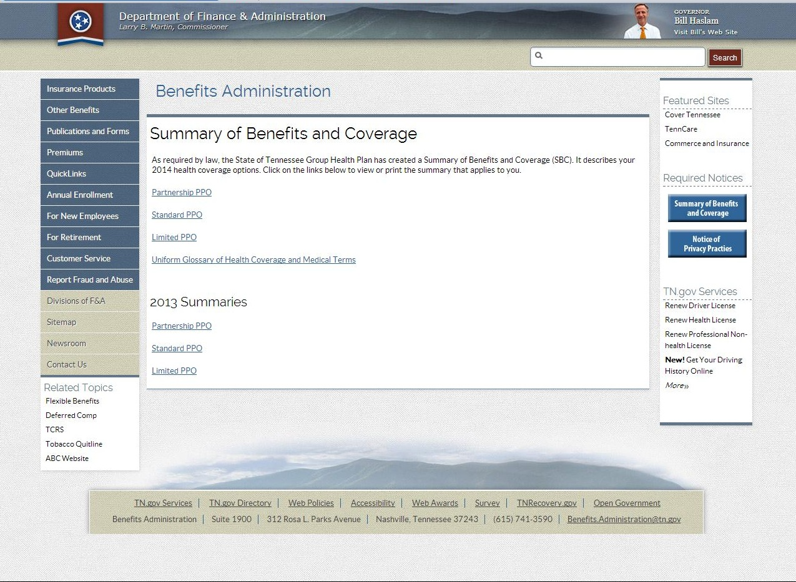

HEALTH

TBR participates in the State of Tennessee's Partners for Health program. Coverage is effective on the 1st of the month following the date of hire. Eligible employees have a choice of two health insurance options and two insurance carriers.

Option 1

Partnership PPO – employees participating in the partnership option will benefit from lower premiums, co-pays, and co-insurance costs. This option requires a pledge to complete a health questionnaire, screening, and routine health services.

  - Blue Cross Blue Shield of Tennessee – S Network
  - Cigna Local Plus
  - Cigna Open Access

Partnership PPO - Employee Health Premiums (monthly)
Coverage Type | BCBST | Cigna  Local  Plus | Cigna Open Access
Employee Only | $114.49 | $114.49 | $134.49
Employee + Child(ren) | $171.73 | $171.73 | $211.72
Employee + Spouse | $240.42 | $240.42 | $280.42
Employee + Spouse + Child(ren) | $297.67 | $297.67 | $337.67

If you are a new Partnership PPO member hired on or after January 1, 2014, you and your covered spouse are required to complete the Partnership Promise. The 2014 Partnership Promise requirements are:

  - Complete the online Well-Being Assessment
  - Complete a biometric health screening
  - Participate in health coaching and/or case management if identified
  - Engage in the tobacco cessation program if you are a tobacco user
  - Update your contact information if it changes

Requirements must be completed within 120 days of your insurance coverage effective date.

Option 2

Standard PPO – employees participating in the standard option are not required to complete the Partnership Promise.

  - Blue Cross Blue Shield of Tennessee – S Network
  - Cigna Local Plus
  - Cigna Open Access

Standard PPO - Employee Health Premiums (monthly)
Coverage Type | BCBST | Cigna  Local  Plus | Cigna Open Access
Employee Only | $139.49 | $139.49 | $159.49
Employee + Child(ren) | $196.73 | $196.73 | $236.73
Employee + Spouse | $290.42 | $290.42 | $330.42
Employee + Spouse + Child(ren) | $347.67 | $347.67 | $387.67

PHARMACY

Your health insurance includes pharmacy benefits. The covered drug list is identical under both the Partnership PPO and the Standard PPO, although co-pays differ between the two. You do not have to make a choice about your pharmacy benefits. This benefit is automatically included with the health insurance option selected.

 | Partnership PPO |  | Standard PPO
 | In-Network | Out-of-Network | In-Network | Out-of-Network
30 day supply | $5 co-pay for generic;  $35 co-pay for preferred brand; $85 co-pay for non-preferred brand | Co-pay, plus any amount exceeding MAC | $10 co-pay for generic;  $45 co-pay for preferred brand; $95 co-pay for non-preferred brand | Co-pay, plus any amount exceeding MAC
90-day supply (90-day network pharmacy or mail-order) | $10 co-pay for generic;  $65 co-pay for preferred brand; $165 co-pay for non-preferred brand | Co-pay, plus any amount exceeding MAC | $20 co-pay for generic;  $85 co-pay for preferred brand; $185 co-pay for non-preferred brand | Co-pay, plus any amount exceeding MAC
90-day supply (certain maintenance medications from 90-day network pharmacy or mail order)) | $5 co-pay for generic;  $30 co-pay for preferred brand; $160 co-pay for non-preferred brand | Co-pay, plus any amount exceeding MAC | $10 co-pay for generic;  $40 co-pay for preferred brand; $180 co-pay for non-preferred brand | Co-pay, plus any amount exceeding MAC

DENTAL

Eligible employees have a choice of two dental insurance carriers. Coverage is effective on the 1st of the month following the date of hire.

Option 1

Assurant Prepaid Plan – employees selecting this option will be required to submit the “Dental Selection Card” upon enrollment.

Option 2

Delta PDO Dental – employees selecting this option will have access to all in-network providers.

Employee Dental Premiums (monthly)
Coverage Type | Assurant Prepaid | Delta PDO
Employee Only | $ 9.92 | $21.07
Employee + Child(ren) | $20.60 | $48.44
Employee + Spouse | $17.58 | $39.85
Employee + Spouse + Child(ren) | $24.17 | $77.98

VISION

Eligible employees have a choice of two vision insurance options and two insurance carriers. Coverage is effective on the 1st of the month following the date of hire.

Option 1

VSP Vision Plan - TBR Sponsored

- Bronze Plan

Bronze Plan - Employee Monthly Vision Premiums *
Coverage Type | Monthly Premium
Employee Only | $3.73
Employee plus Child(ren) | $7.99
Employee plus Spouse | $7.46
Family | $12.78

- Gold Plan

Gold Plan - Employee Monthly Vision Premiums*
Coverage Type | Monthly Premium
Employee Only | $8.10
Employee plus Child(ren) | $17.34
Employee plus Spouse | $16.22
Family | $27.73

*Monthly premiums include a 6% administrative fee.

Option 2

EyeMed Vision Plan - State Sponsored

- Basic Plan

Basic Plan - Employee Monthly Vision Premiums
Coverage Type | Monthly Premium
Employee Only | $3.27
Employee plus Child(ren) | $6.54
Employee plus Spouse | $6.21
Family | $9.61

- Expanded Plan

Expanded Plan - Employee Monthly Vision Premiums
Coverage Type | Monthly Premium
Employee Only | $5.73
Employee plus Child(ren) | $11.46
Employee plus Spouse | $10.89
Family | $16.84

LONG TERM DISABILITY

Long-term Disability (LTD) provides income protection in the event an employee becomes disabled due to a covered sickness or accidental bodily injury. There are three options to choose from:

- Option 1 – 180 day elimination period and replaces up to 50% of monthly income.
- Option 2 – 120 day elimination period and replaces up to 60% of monthly income.
- Option 3 – 90 day elimination period and replaces up to 60% of monthly income.

SUPPLEMENTAL LIFE

Optional term life insurance is available at group rates on an employee paid basis for employees and eligible dependents. Minnesota Life Insurance Company, a Securian Company, underwrites the plan.
To enroll, call the toll free number provided in the enclosed information or visit the website to enroll online.
Employees will be required to provide their Edison ID number in order to enroll.
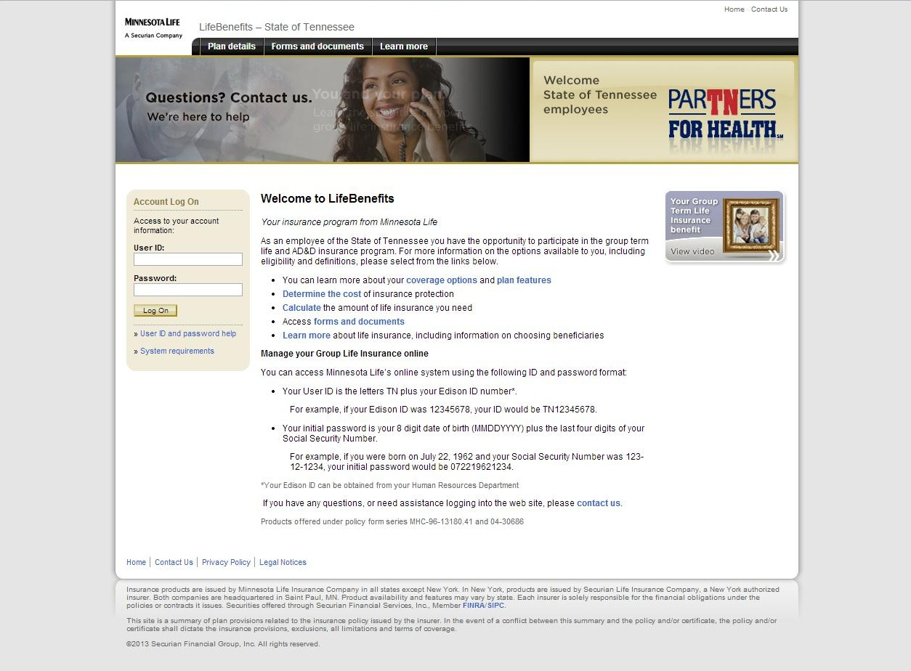

VOLUNTARY DEFERRED COMPENSATION

In addition to the employer provided retirement program, TBR offers several deferred compensation plans to allow employees to save for retirement on a tax-deferred basis. Contributions to these plans are made through regular payroll deductions. Salary set aside through these plans cannot be withdrawn before separation from service except under a few limited circumstances. Participants in these plans are permitted to direct their contributions among a variety of investment options. TBR matches up to $50.00 per month of employee contributions in the 401k plan only.
The following retirement savings plans are operated by the State of Tennessee Treasury Department:
- 457
- 401(k) – Employer Match up to $50 per month
- 403(b)
- 401(k) Roth (after-tax)
Please visit the state’s Deferred Compensation Program’s Web site or the Office of Human Resources for additional information.

FLEXIBLE SPENDING ACCOUNT (FSA)

A Flexible Spending Account permits employees to set aside a specified number of pre-tax dollars up to an annual maximum for use for purposes permitted by the Internal Revenue Service. In general, these are certain types of childcare expenses and certain types of health-related expenses. TBR's flexible benefits plan is administered by the Fringe Benefits Management Company.

AFLAC

Hospital Indemnity – Level 1
(Group Supplemental Hospital Indemnity –#CAI8576hsa)

Monthly Premiums* Benefits
Ages 18 - 64  $16.89 | The Supplemental Hospital Indemnity plan provides benefits for inpatient as a result of covered accidents and sickness. Please refer to the Group Supplemental Hospital Indemnity Brochure for specific benefits, definitions, and exclusions.

*Monthly premiums include a 6% administrative fee.

Accident
(Group Accident 24-Hour Coverage - #CAI7776TN)

Monthly Premiums* Description
Ages 18 – 69  $17.09 | Group Accident insurance pays a benefit for the treatment of injuries suffered as the result of a covered accident. Benefits are paid regardless of any other health insurance benefits the insured may receive. Please refer to the Group Accident Brochure for specific benefits, definitions, and exclusions.

*Monthly premiums include a 6% administrative fee.

Critical Illness
(Group Critical Illness - #CAI2876TN)

Monthly Premiums* Description
Non- Tobacco Rates:  First $5,000 of coverage  Ages 18 to 29 $ 5.07  Ages 30 to 39 $ 6.71  Ages 40 to 49 $10.47  Ages 50 to 59 $16.46  Ages 60 to 69 $24.68  Tobacco Rates:  First $5,000 of coverage  Ages 18 to 29 $ 6.39  Ages 30 to 39 $ 9.31  Ages 40 to 49 $18.53  Ages 50 to 59 $29.76  Ages 60 to 69 $45.88 | Group Critical Illness provides a lump-sum benefit upon the diagnosis of not only one covered illness, but for each covered illness. Please refer to the Group Critical Illness Brochure for specific benefits, definitions, and exclusions.

*Monthly premiums include a 6% administrative fee.

Personal Sickness Indemnity
(Individual Hospital Confinement Sickness Indemnity –#A45075B1TN)

Monthly Premiums* Description
Ages 18 to 39 $21.41  Ages 40 to 49 $23.96  Ages 50 to 59 $29.79  Ages 60 to 64 $41.45 | Individual Hospital Confinement Sickness Indemnity provides cash benefits directly, which can be used for treatment costs or everyday bills. Please refer to the Individual Hospital Confinement Sickness Indemnity Brochure for specific benefits, definitions, and exclusions.

*Monthly premiums include a 6% administrative fee.

Cancer Indemnity
(Individual Maximum Difference Essentials –#A761ESTN)

Monthly Premiums* Description
Ages 18 to 35 $11.99  Ages 36 to 45 $14.74  Ages 46 to 55 $19.43  Ages 56 to 70 $24.94 | Individual Maximum Difference Essentials provides cash benefits directly, which can be used for treatment costs or everyday bills. Please refer to the Individual Maximum Difference Essentials Brochure for specific benefits, definitions, and exclusions.

*Monthly premiums include a 6% administrative fee.

To enroll, please visit complete the enclosed “AFLAC Interest Form” and return to Human Resources.

Long Term Care
Long Term Care plan available through MedAmerica. To enroll in MedAmerica, Long Term Care insurance visit the following web address:
http://yourlongtermcare.com/enrollment/enroll.jsp

Benefits are an important part of your total compensation. Be sure to take time to review your choices and select the best benefits for you and your family.

This guide contains a summary of benefit features. It does not describe all benefits and benefit limitations under the plans. For a complete description of benefits you must refer to the plan documents.

DISTRIBUTION ITEMS

- Title IX Fact Sheet
- Title VI Handout
- Reporting and Preventing Fraud, Waste, or Abuse
- Organizational Charts
- Phone List
- Job Description

checklist

New Hire Paperwork ☑

Employee Data Form
Voluntary Self-Identification Form
I-9 (identification verified)
W-4
Direct Deposit Authorization
*Designation of Beneficiary Form
Computer Account Application
Office Key Request Form
Payroll Deduction Authorization Form

Policies ☑

Drug Free Workplace Acknowledgment Form
Computer Usage Acknowledgment Form
Outside Employment Acknowledgment Form

Training ☑

Sexual Harassment – Certificate of Completion
Title VI – Certificate of Completion

Distribution Items ☑

Job Description (original signed & copy to employee)
*Must be notarized | HR Initials: | Date:

